SIMATS ENGINEERING (SAVEETHA SCHOOL OF ENGINEERING)

Department of Artificial Intelligence and Data Science
ASSESSMENT TOOL 2 – SCENARIO BASED

Course Code: | DSA03 | Course Title: | Natural Language Processing
CO Assessed: | CO2 – Manipulation | Assessment: | Assessment Tool 2 – SCENARIO BASED
Weightage: | 35% of CIA
CO5 Statement: | Design inflectional, derivational, finite-state parsing, stemming algorithms and for analyse morphological methods. (BL-3)
Student Name: | K. Deeksha Sree | Reg. No.: | 192424097
Section / Batch: | 2024-C | Date: | 5-8-2026
Code of Conduct
I K.Deeksha Sree(192424097) (Name / Reg No) certify that this submission is my original work and that I have adhered to the guidelines specified for this assessment. I understand that any violation of academic integrity rules will result in disciplinary action.
Signature of the Student: Deeksha
Instructions
- Read all questions carefully before attempting the answers.
- Answer all five questions. Each question carries equal marks.
- Show all intermediate steps, calculations, probability computations, tagging decisions, and justifications wherever applicable.
- Duration: 30 minutes.

Section / Topic | Focus | Q Nos
English Word Classes, Tagsets for English, Stochastic Part of Speech Tagging, HMM | Morphological parsing of disagree, agreement, and agreeable; identification of prefixes, suffixes, base forms, and semantic effects of derivation. | Q1

Annexure A – SCENARIO BASED
A company is developing an NLP-based grammar checker for educational applications. The system is trained using a manually POS-tagged corpus. Your task is to recreate the Hidden Markov Model (HMM) without using any built-in NLP or HMM libraries.
From the given corpus,
- determine the Emission Probability
- determine the Transition Probability
- implement the Viterbi Algorithm
- predict the POS tags for the new input sentence.
Use only Python dictionaries, loops, and basic programming constructs.

Training Corpus

Sentence POS Tags
The/DT boy/NN eats/VBZ rice/NN DT NN VBZ NN The/DT girl/NN drinks/VBZ milk/NN DT NN VBZ NN A/DT cat/NN drinks/VBZ milk/NN DT NN VBZ NN The/DT dog/NN chases/VBZ cat/NN DT NN VBZ NN A/DT teacher/NN teaches/VBZ students/NNS DT NN VBZ NNS Students/NNS study/VBP English/NN NNS VBP NN Birds/NNS fly/VBP high/RB NNS VBP RB Children/NNS play/VBP games/NNS NNS VBP NNS

New Input Sentence
The cat drinks milk

Tasks
- Separate each sentence into words and POS tags.
- Compute the Emission Probability of every word.
- Compute the Transition Probability between POS tags.
- Recreate the Hidden Markov Model using Python dictionaries.
- Implement the Viterbi Algorithm without using any built-in HMM/NLP libraries.
- Predict the POS tag sequence for “The cat drinks milk”

Rubrics for Calculation

Criteria | Weighta ge (%) | Level 4 (Exemplary) | Level 3 (Proficient) | Level 2 (Developing) | Level 1 (Beginning)
Understanding of Scenario | 20% | Demonstrates clear and complete understanding of  the scenario and context | Shows good understanding with minor gaps | Partial understanding; misses key aspects | Misinterprets or fails to understand the scenario
Identification of Key Issues | 20% | Accurately identifies all  relevant issues and factors involved | Identifies most key issues with minor omissions | Identifies limited issues; some irrelevant points | Unable to identify key issues
Application of Concepts | 25% | Applies appropriate concepts effectively  to address the scenario | Applies concepts with minor errors | Limited or partially correct application | Unable to apply relevant concepts
Decision Making | 20% | Makes well-reasoned, logical decisions with strong rationale | Makes reasonable decisions with some justification | Makes weak decisions with limited justification | No clear decisions made or rationale provided
Clarity of Response | 15% | Response is clear, structured, and logically presented | Generally clear with minor issues | Somewhat unclear or poorly  structured | Disorganized and difficult to understand

Q. No. / Criteria Level | Understanding of Scenario | Identification of Key Issues | Application of Concepts | Decision Making | Clarity of Response | Sub. Total | Total  %
1 | 20 | 20 | 25 | 20 | 12 | 97 | 97

Faculty In-charge | Course Coordinator | Program Director
Dr.T.Kumaragurubaran
Signature: | Signature: | Signature:
Date: | Date: | Date:

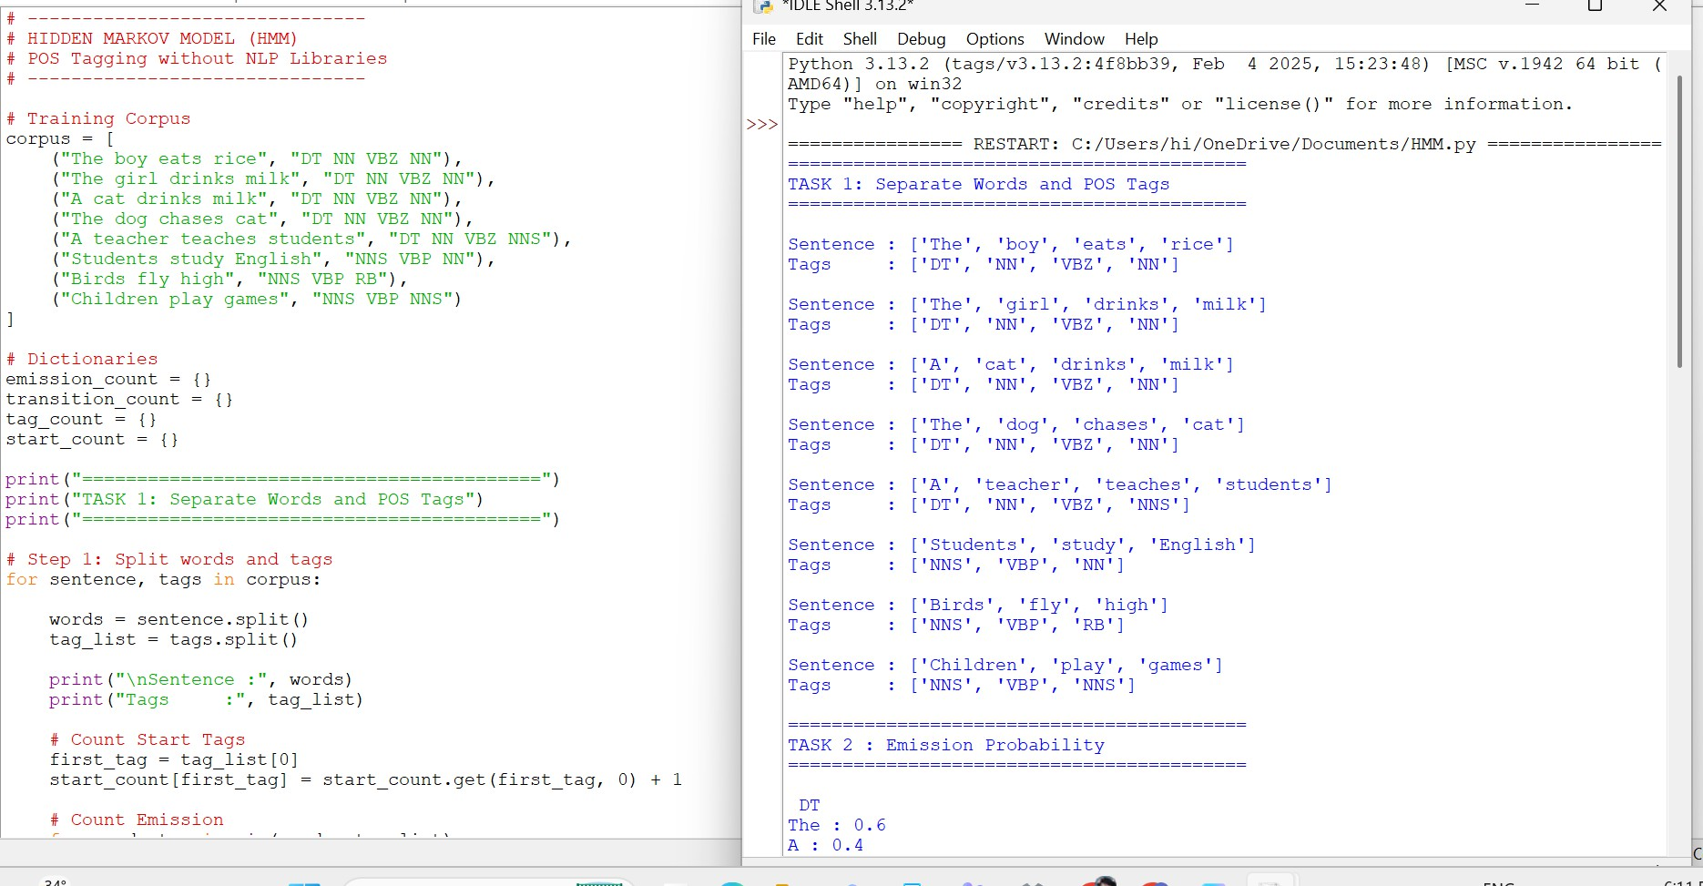
1.

#
# HIDDEN MARKOV MODEL (HMM)
# POS Tagging without NLP Libraries #

# Training Corpus corpus = [
("The boy eats rice", "DT NN VBZ NN"), ("The girl drinks milk", "DT NN VBZ NN"), ("A cat drinks milk", "DT NN VBZ NN"), ("The dog chases cat", "DT NN VBZ NN"),
("A teacher teaches students", "DT NN VBZ NNS"), ("Students study English", "NNS VBP NN"),
("Birds fly high", "NNS VBP RB"), ("Children play games", "NNS VBP NNS")
]

# Dictionaries emission_count = {} transition_count = {} tag_count = {} start_count = {}

print("==========================================")
print("TASK 1: Separate Words and POS Tags") print("==========================================")

# Step 1: Split words and tags for sentence, tags in corpus:

words = sentence.split() tag_list = tags.split()

print("\nSentence :", words) print("Tags :", tag_list)

# Count Start Tags first_tag = tag_list[0]
start_count[first_tag] = start_count.get(first_tag, 0) + 1

# Count Emission
for word, tag in zip(words, tag_list):
tag_count[tag] = tag_count.get(tag, 0) + 1 if tag not in emission_count:
emission_count[tag] = {}
emission_count[tag][word] = emission_count[tag].get(word, 0) + 1 # Count Transition
for i in range(len(tag_list)-1):

current = tag_list[i] nxt = tag_list[i+1]

if current not in transition_count: transition_count[current] = {}

transition_count[current][nxt] = transition_count[current].get(nxt, 0) + 1

#
# TASK 2 : Emission Probability #

print("\n==========================================")
print("TASK 2 : Emission Probability") print("==========================================")

emission = {}

for tag in emission_count: emission[tag] = {} print("\n", tag)
for word in emission_count[tag]:

probability = emission_count[tag][word] / tag_count[tag] emission[tag][word] = probability
print(word, ":", round(probability,3))

#

# TASK 3 : Transition Probability #

print("\n==========================================")
print("TASK 3 : Transition Probability") print("==========================================")

transition = {}

for tag in transition_count: transition[tag] = {}
total = sum(transition_count[tag].values()) for nxt in transition_count[tag]:
probability = transition_count[tag][nxt] / total transition[tag][nxt] = probability
print(tag,"->",nxt,"=",round(probability,3))

#
# Start Probability #

start_probability = {} total_sentences = len(corpus) for tag in start_count:
start_probability[tag] = start_count[tag] / total_sentences

#
# TASK 4 : Hidden Markov Model #

print("\n==========================================")
print("TASK 4 : Hidden Markov Model") print("==========================================")

print("\nStart Probability") print(start_probability)

print("\nEmission Probability") print(emission)

print("\nTransition Probability") print(transition)

#

# TASK 5 : Viterbi Algorithm #

print("\n==========================================")
print("TASK 5 : Viterbi Algorithm") print("==========================================")

sentence = input("\nEnter a sentence : ").split() tags = list(emission.keys())
V = {}
path = {}

# Initialization first_word = sentence[0] for tag in tags:
emit = emission[tag].get(first_word,0) start = start_probability.get(tag,0)
if emit > 0 and start > 0: V[tag] = start * emit path[tag] = [tag]
# Recursion
for word in sentence[1:]: newV = {}
newPath = {}

for current_tag in tags:
emit = emission[current_tag].get(word,0) if emit == 0:
continue

best_probability = 0 best_previous = None

for previous_tag in V:

trans = transition.get(previous_tag,{}).get(current_tag,0) probability = V[previous_tag] * trans * emit
if probability > best_probability: best_probability = probability

best_previous = previous_tag if best_previous is not None:
newV[current_tag] = best_probability
newPath[current_tag] = path[best_previous] + [current_tag]

V = newV
path = newPath

#
# TASK 6 : Prediction #

print("\n==========================================")
print("TASK 6 : Predicted POS Tags") print("==========================================")

if len(V)==0:

print("No valid tag sequence found.") else:
best_tag = max(V,key=V.get) predicted = path[best_tag] print("\nSentence :", " ".join(sentence)) print("\nPredicted Tags :")
for word,tag in zip(sentence,predicted): print(word,"/",tag)
print("\nTag Sequence :") print(" ".join(predicted))

output:
Python 3.13.2 (tags/v3.13.2:4f8bb39, Feb 4 2025, 15:23:48) [MSC v.1942 64 bit (AMD64)] on win32 Type "help", "copyright", "credits" or "license()" for more information.

================ RESTART: C:/Users/hi/OneDrive/Documents/HMM.py ================
==========================================
TASK 1: Separate Words and POS Tags
==========================================

Sentence : ['The', 'boy', 'eats', 'rice']
Tags : ['DT', 'NN', 'VBZ', 'NN']

Sentence : ['The', 'girl', 'drinks', 'milk']
Tags : ['DT', 'NN', 'VBZ', 'NN']

Sentence : ['A', 'cat', 'drinks', 'milk']
Tags : ['DT', 'NN', 'VBZ', 'NN']

Sentence : ['The', 'dog', 'chases', 'cat']
Tags : ['DT', 'NN', 'VBZ', 'NN']

Sentence : ['A', 'teacher', 'teaches', 'students']
Tags : ['DT', 'NN', 'VBZ', 'NNS']

Sentence : ['Students', 'study', 'English'] Tags : ['NNS', 'VBP', 'NN']

Sentence : ['Birds', 'fly', 'high']
Tags : ['NNS', 'VBP', 'RB']

Sentence : ['Children', 'play', 'games']
Tags : ['NNS', 'VBP', 'NNS']

==========================================
TASK 2 : Emission Probability
==========================================

DT
The : 0.6
A : 0.4

NN
boy : 0.1
rice : 0.1
girl : 0.1
milk : 0.2
cat : 0.2
dog : 0.1
teacher : 0.1
English : 0.1

VBZ
eats : 0.2
drinks : 0.4
chases : 0.2
teaches : 0.2

NNS
students : 0.2
Students : 0.2
Birds : 0.2
Children : 0.2
games : 0.2

VBP
study : 0.333
fly : 0.333
play : 0.333 RB

high : 1.0

==========================================
TASK 3 : Transition Probability
========================================== DT -> NN = 1.0
NN -> VBZ = 1.0 VBZ -> NN = 0.8 VBZ -> NNS = 0.2 NNS -> VBP = 1.0 VBP -> NN = 0.333 VBP -> RB = 0.333 VBP -> NNS = 0.333

==========================================
TASK 4 : Hidden Markov Model
==========================================

Start Probability
{'DT': 0.625, 'NNS': 0.375}

Emission Probability
{'DT': {'The': 0.6, 'A': 0.4}, 'NN': {'boy': 0.1, 'rice': 0.1, 'girl': 0.1, 'milk': 0.2, 'cat': 0.2, 'dog': 0.1, 'teacher': 0.1,
'English': 0.1}, 'VBZ': {'eats': 0.2, 'drinks': 0.4, 'chases': 0.2, 'teaches': 0.2}, 'NNS': {'students': 0.2, 'Students': 0.2,
'Birds': 0.2, 'Children': 0.2, 'games': 0.2}, 'VBP': {'study': 0.3333333333333333, 'fly': 0.3333333333333333, 'play':
0.3333333333333333}, 'RB': {'high': 1.0}}

Transition Probability
{'DT': {'NN': 1.0}, 'NN': {'VBZ': 1.0}, 'VBZ': {'NN': 0.8, 'NNS': 0.2}, 'NNS': {'VBP': 1.0}, 'VBP': {'NN':
0.3333333333333333, 'RB': 0.3333333333333333, 'NNS': 0.3333333333333333}}

==========================================
TASK 5 : Viterbi Algorithm
==========================================

Enter a sentence : the cat drink milks

==========================================
TASK 6 : Predicted POS Tags
==========================================
No valid tag sequence found.

